PENETRATION TESTING REPORT
FOOTPRINTING & NETWORK SCANNING PHASES
W2-PM-FINAL | CYBERSECURITY | NETWORKWALKS

Pentester Name  (Cybersecurity Professional) | Yash Raj
Program/Batch | B084-Networkwalks
Date | 13 November 2026
Modules completed | W2-PM1 (Multiple Kali Tools)  W2-PM3 (Maltego)  W2-PM5 (Zenmap Scanning)
Client/Target | 1. Networkwalks (secured written permission already)  2. My own local LAN Network
Permission secured from client? | Yes
Phases covered | Phase 1: Reconnaissance & Footprinting  Phase 2: Scanning & Network Discovery  Phase 3-5: In Progress

1. Liability Disclaimer
I have performed these activities only on the systems & devices where I had secured written permission or the devices/systems that I own myself. All these materials are for education and research purpose only. Do not use anything from here to break the law. The instructor, the authors and Networkwalks are not responsible for what you do with this knowledge. Every action you take is your own responsibility. Misuse can lead to criminal charges, heavy fines, loss of your job and a permanent record. In most countries unauthorized access is a crime even when nothing is damaged.

2. Introduction
This report documents the practical activities performed during Week 2 of my Cybersecurity & Ethical Hacking internship at Networkwalks. The report covers three distinct modules: Footprinting using multiple Kali Linux tools (W2-PM1), Footprinting using Maltego (W2-PM3), and Network Scanning using Zenmap (W2-PM5).

The objective of these modules was to understand how an attacker gathers publicly available information (OSINT) and maps out a network. All reconnaissance activities were performed against networkwalks.com (with written permission), and scanning activities were performed on my own local LAN. Each section below details the exact steps taken, the commands used, the results obtained, and the security implications of those findings..

3. Tools Used
The table below lists the tools utilized across all three modules and their specific purposes.
Tool | Modules | Purpose
Kali Linux & Windows | All | Operating systems used for practical execution
WHOIS | W2-PM1 | Extract domain registration details and name servers.
whatweb | W2-PM1 | Fingerprint web technologies (CMS, server, plugins).
nslookup | W2-PM1 | Resolve the target domain to its IPv4 address.
curl -I | W2-PM1 | Inspect HTTP response headers.
wafw00f | W2-PM1 | Detect Web Application Firewall (WAF).
dnsrecon | W2-PM1 | Enumerate DNS records (NS, MX, SRV, etc.).
Maltego | W2-PM3 | OSINT tool to visually map and harvest email addresses.
Windows CMD | W2-PM5 | Identify local IP configuration (ipconfig).
Zenmap (Nmap GUI) | W2-PM5 | Perform Ping Scans to discover live hosts and generate topology.

4. Activities Performed

4.1 W2-PM1: Footprinting & Reconnaissance

In this module, I used six different tools in Kali Linux to gather information about the target networkwalks.com.

· WHOIS: I executed the whois networkwalks.com command. The output revealed that the domain is registered through GoDaddy.com, LLC and was created on 2019-11-06. It also exposed the primary name servers as NS6135.HOSTGATOR.COM and NS6136.HOSTGATOR.COM.
· WhatWeb: Running whatweb networkwalks.com allowed me to fingerprint the website. The scan revealed the site uses an Apache server, runs on WordPress 7.1.4, and uses the WP Download Manager 3.3.76 plugin. It also exposed the target IP (192.232.216.135) and an administrative email address (info@networkwalks.com).
· Nslookup: Using the nslookup networkwalks.com command, I resolved the domain name to confirm its IP address is 192.232.216.135.
· Curl: By running curl -I https://networkwalks.com, I inspected the HTTP response headers. The output confirmed the server is Apache and revealed the presence of the WordPress REST API endpoint (/wp-json/).
· Wafw00f: I used wafw00f networkwalks.com to check for security defences. The tool successfully identified that the website is protected by ModSecurity (SpiderLabs) WAF.
· DNSRecon: Running dnsrecon -d networkwalks.com enumerated further DNS records. It provided detailed information on Name Servers, Mail Servers (mail.networkwalks.com), and SRV records (cpanelmaildiscovery).

4.2 W2-PM3: Maltego based Footprinting
For this module, I utilized Maltego Graph to perform OSINT (Open Source Intelligence) gathering to find email addresses associated with the target domain.

· I opened Maltego, searched for the Domain entity from the Palette, and dragged it onto the main graph area.
· I double-clicked the entity and renamed it to networkwalks.com.
· Next, I right-clicked the domain entity, opened the Run Transforms menu, and selected "To Emails @domain [Search Engine]".
· The transform successfully executed and harvested email addresses related to the domain. The graph visually mapped the domain to the email address info@networkwalks.com.
· Attacker Perspective: This information is highly valuable for social engineering, phishing campaigns, or brute-force attacks against mail servers.

4.3 W2-PM5: Network Scanning with Zenmap
In this module, I used Zenmap (the official Nmap GUI) on a Windows machine to map my local network.

· Host Discovery: First, I opened the Windows Command Prompt and ran ipconfig. This identified my local IPv4 address as 172.16.7.59 with a Subnet Mask of 255.255.255.0 (Subnet: 172.16.7.0/24).
· Scanning: I opened Zenmap, entered the target as 172.16.7.0/24, and selected the "Ping scan" profile to discover live hosts without doing a full port scan.
· Results: The scan successfully discovered 4 live hosts in the subnet. By clicking on the "Hosts" tab and checking the Nmap Output, I gathered the following details:
· 172.16.7.51 (MAC: EC:74:D7:19:F7:8A - Grandstream Networks)
· 172.16.7.59 (My local PC)
· 172.16.7.76 (MAC: EC:74:D7:19:F7:80 - Grandstream Networks)
· 172.16.7.178 (MAC: E0:1C:FC:65:39:32 - D-Link International)
· Topology Mapping: Finally, I clicked on the "Topology" tab in Zenmap, enabled the legend, and saved the visual network map as a PDF file (zenmap.pdf).

5. Risk Analysis / Impact
Based on the intelligence gathered across the three modules, the following risks were identified:
# | Risk / Finding | Evidence / Observation | Potential Impact | Risk Level
1 | Outdated/Exposed CMS and Plugins | WhatWeb identified WordPress 7.1.4 and WP Download Manager 3.3.76. | Attackers can search for specific exploits targeting these versions. | ● Critical
2 | Email Harvesting (OSINT) | Maltego and WhatWeb exposed info@networkwalks.com | Facilitates targeted phishing (Spear-phishing) and social engineering. | ● Medium
3 | WAF Identification | Wafw00f identified ModSecurity. | Attackers know which WAF to bypass or tailor their payloads for. | ● Low
4 | Infrastructure Details Exposed | WHOIS and DNSRecon exposed Hostgator Name Servers and Mail Servers. | Helps attackers map the hosting infrastructure and target mail servers. | ● Low
5 | Live Hosts & Vendor Info Discovered | Zenmap found 4 live hosts and identified MAC vendors (Grandstream, D-Link). | In a real attack, these devices (e.g., IP phones/routers) could be targeted for default credential attacks. | ● Medium

Risk level key: ● Critical ● Medium ● Low
Note: These are observations from reconnaissance, not confirmed exploitable vulnerabilities. No exploitation was performed.

6. Recommendations
Based on the observations from these activities, I recommend the following security improvements:
- Update Web Technologies: Ensure WordPress core, themes, and plugins (like WP Download Manager) are updated to the latest versions to patch known vulnerabilities.
- Protect Email Addresses: Avoid displaying direct email addresses (like info@networkwalks.com) in plain text on public websites. Use contact forms or obfuscate emails to prevent OSINT harvesting.
- Harden WAF Rules: Since ModSecurity is in use, ensure it is properly tuned to block common OSINT tools and scanning attempts.
- Network Monitoring: Organizations should regularly perform authorized scans (like the Zenmap ping sweep) to identify unauthorized devices connected to their network.
- MAC Filtering: Implement MAC filtering or Network Access Control (NAC) to prevent unauthorized devices from connecting to the LAN.

7. Conclusion
This week’s project work successfully covered three crucial phases of the penetration testing lifecycle: Footprinting (W2-PM1), OSINT-based Footprinting using Maltego (W2-PM3), and Network Scanning with Zenmap (W2-PM5). Each module provided hands-on experience with industry-standard tools and demonstrated how an attacker systematically gathers information about a target before attempting any exploitation.
In W2-PM1, I used six different Kali Linux tools (WHOIS, WhatWeb, Nslookup, Curl, Wafw00f, and DNSRecon) to build a comprehensive profile of networkwalks.com. This exercise revealed how much sensitive information is publicly available — domain registration details, hosting provider (GoDaddy/Hostgator), CMS and plugin versions (WordPress 7.1.4 and WP Download Manager 3.3.76), the presence of a ModSecurity WAF, and even an administrative email address (info@networkwalks.com). The key takeaway was that even without any intrusive scanning, a wealth of data can be harvested, which can later be used for targeted attacks.
In W2-PM3, I used Maltego to perform OSINT gathering and visually map the relationship between the target domain and associated email addresses. The transform successfully harvested info@networkwalks.com, demonstrating how Maltego can automate the collection of publicly available data from search engines. This module highlighted the power of graphical link analysis in threat intelligence and social engineering — an attacker can quickly identify key personnel and contact points, making phishing campaigns more convincing. The visual graph also made it easier to see connections that might be missed in raw text output.
In W2-PM5, I shifted from external reconnaissance to internal network scanning on my own local LAN (172.16.7.0/24). Using Zenmap (Nmap GUI), I performed a ping scan that discovered four live hosts, including devices from Grandstream Networks and D-Link. The topology mapping feature provided a clear visual representation of the network. This module was particularly valuable because it mimicked the early stages of an internal penetration test — identifying live hosts without triggering port scans, and understanding the device landscape. It also reinforced the importance of network visibility for both attackers and defenders.
All activities were conducted strictly within the authorized scope provided by Networkwalks and on my own local network. This practical exercise reinforced not only technical skills but also the ethical and legal responsibilities of a penetration tester. The findings and recommendations in this report can help the client strengthen their security posture and reduce the risk of targeted attacks.

8. Evidences Collected

whois

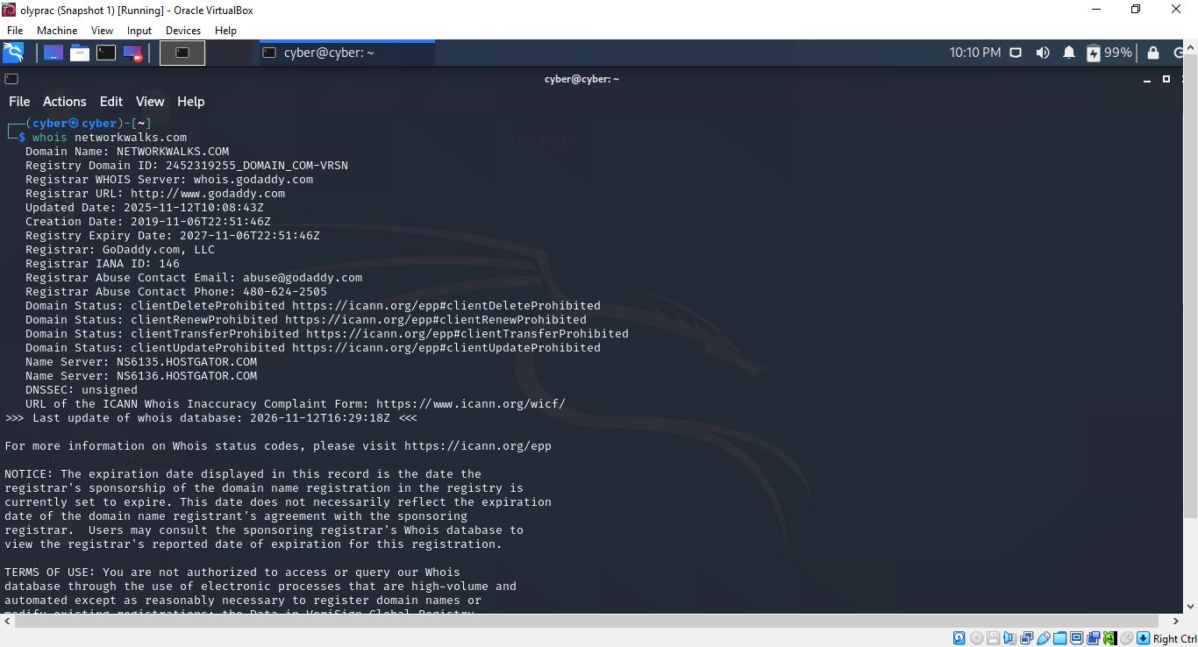
whatweb
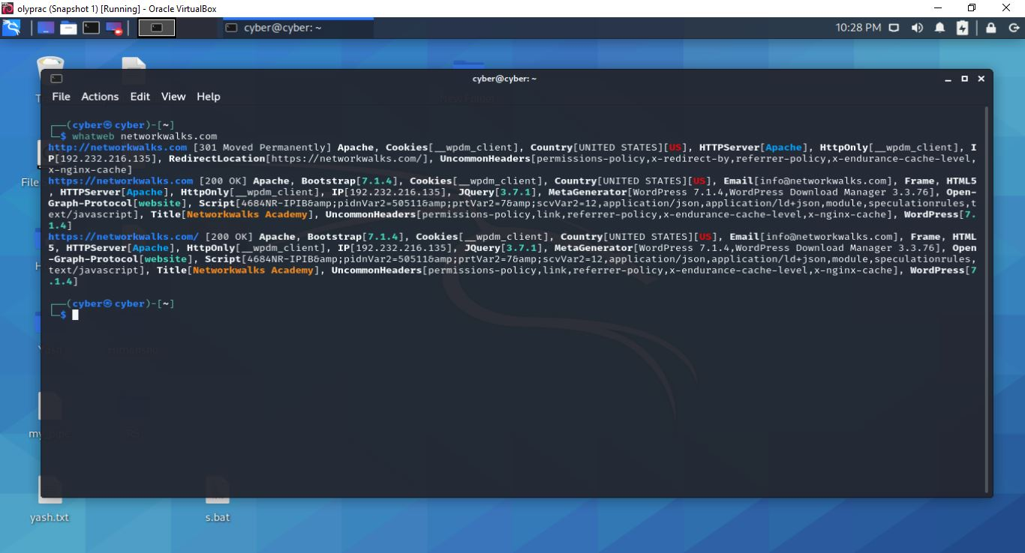

nslookup

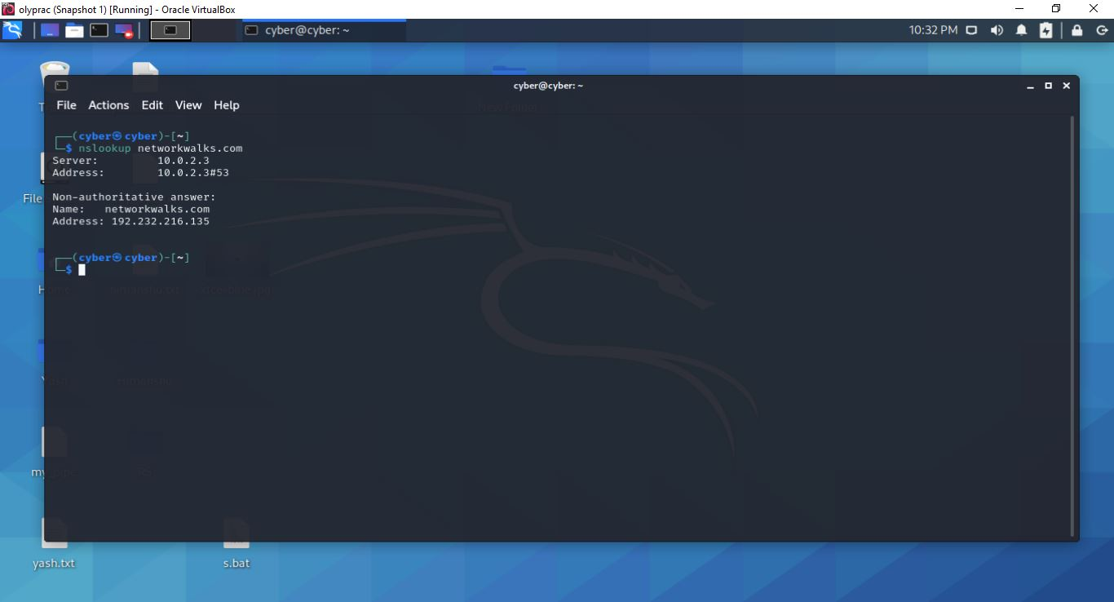
curl -I
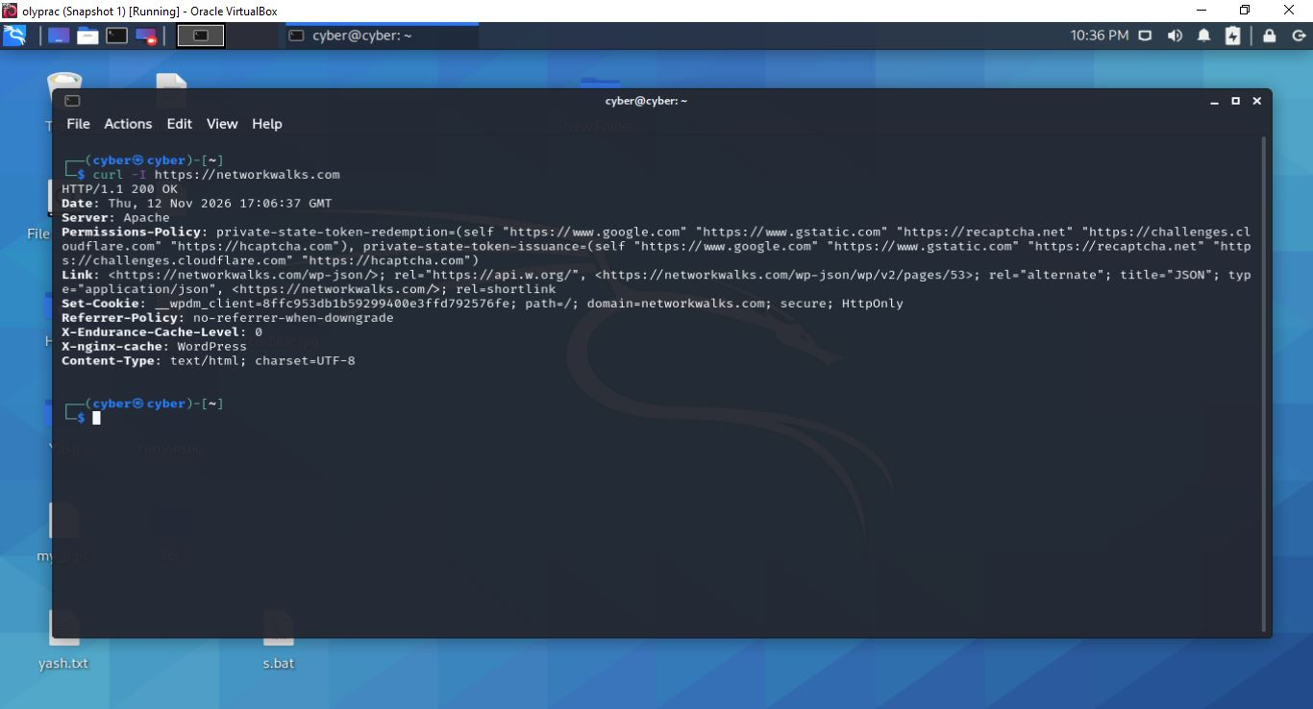

wafw00f

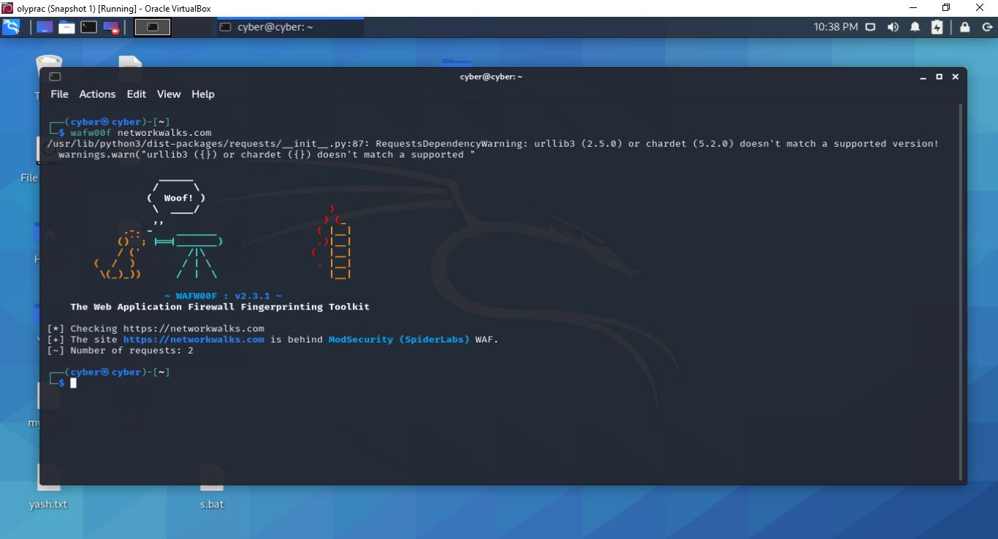
dnsrecon
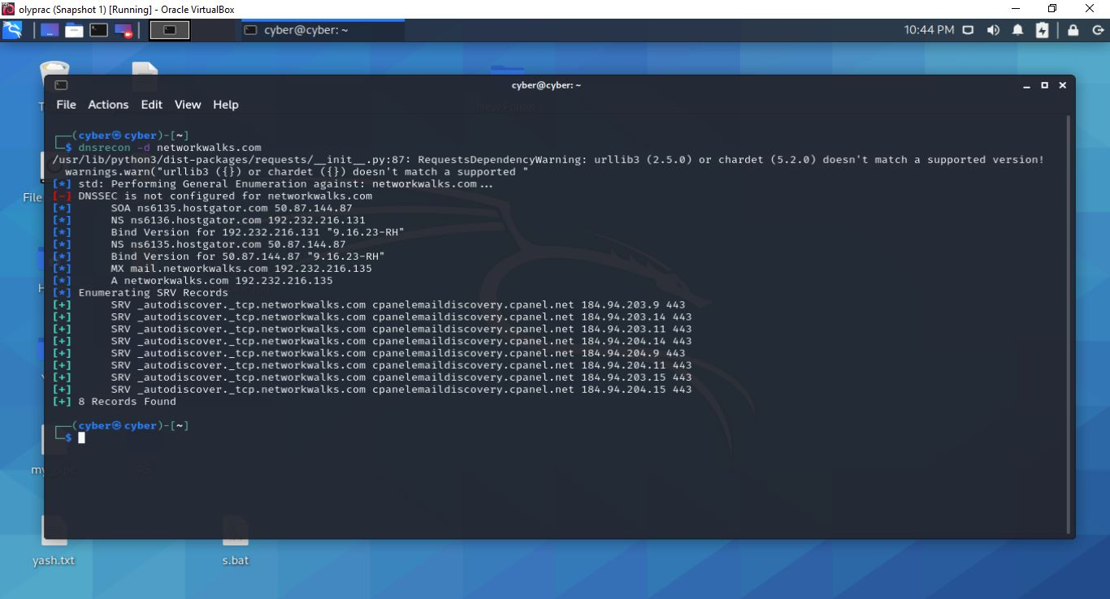

Maltego
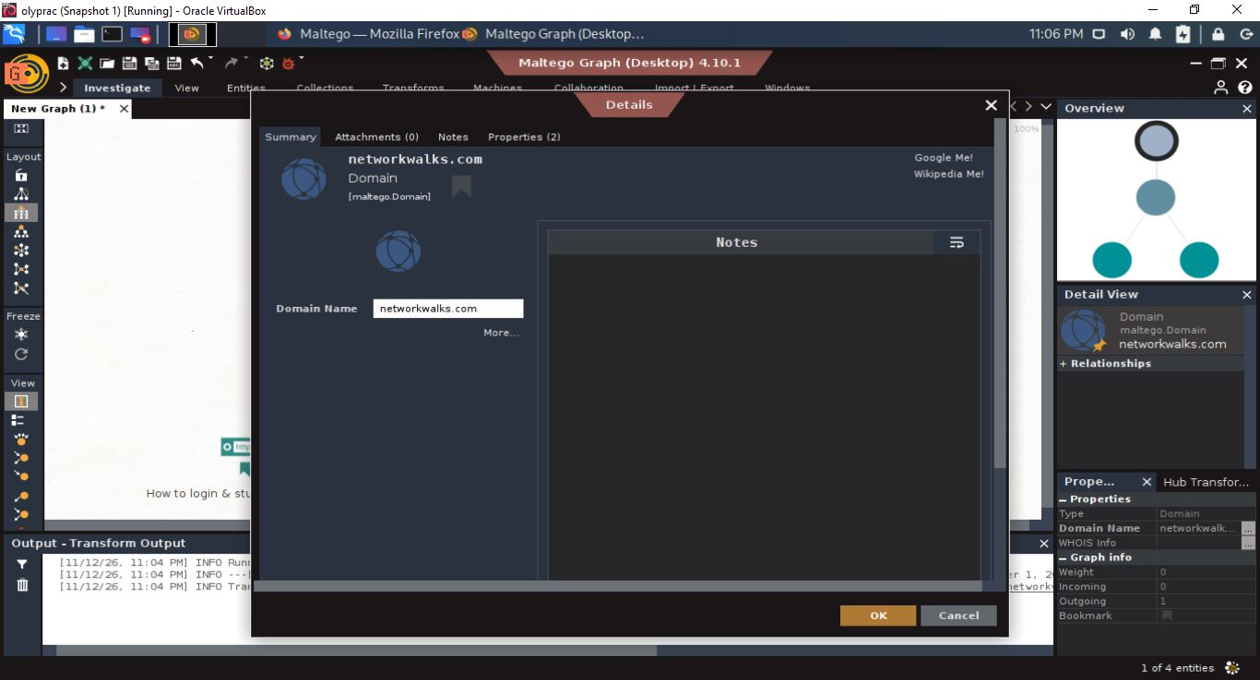
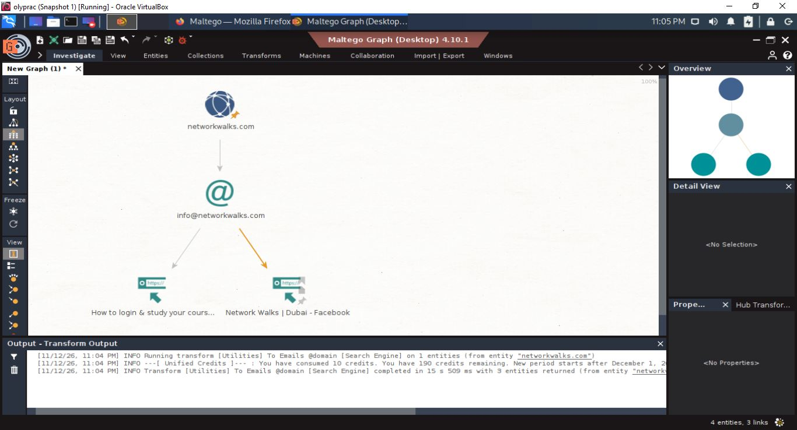

ZenMap
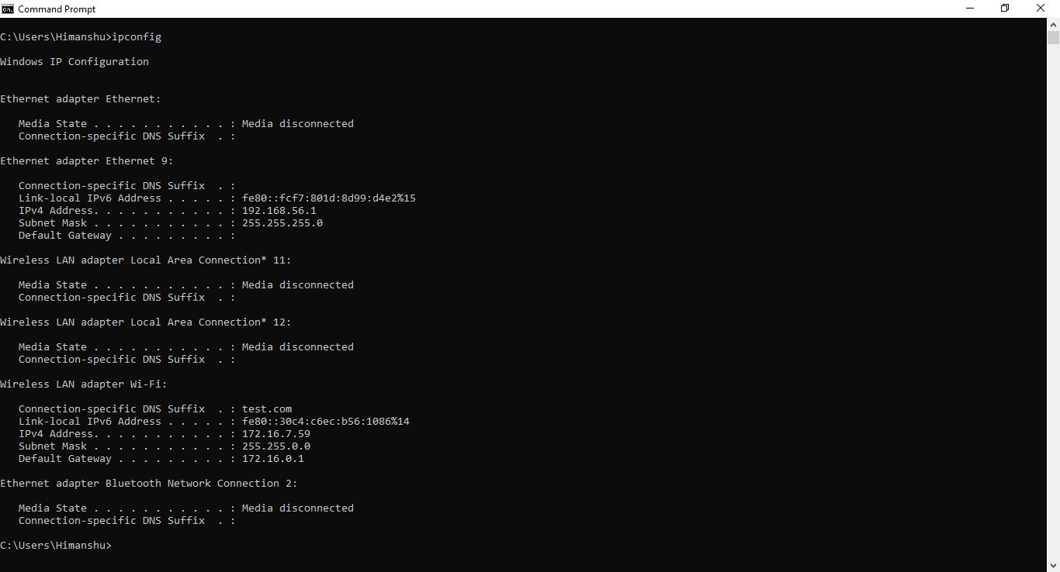

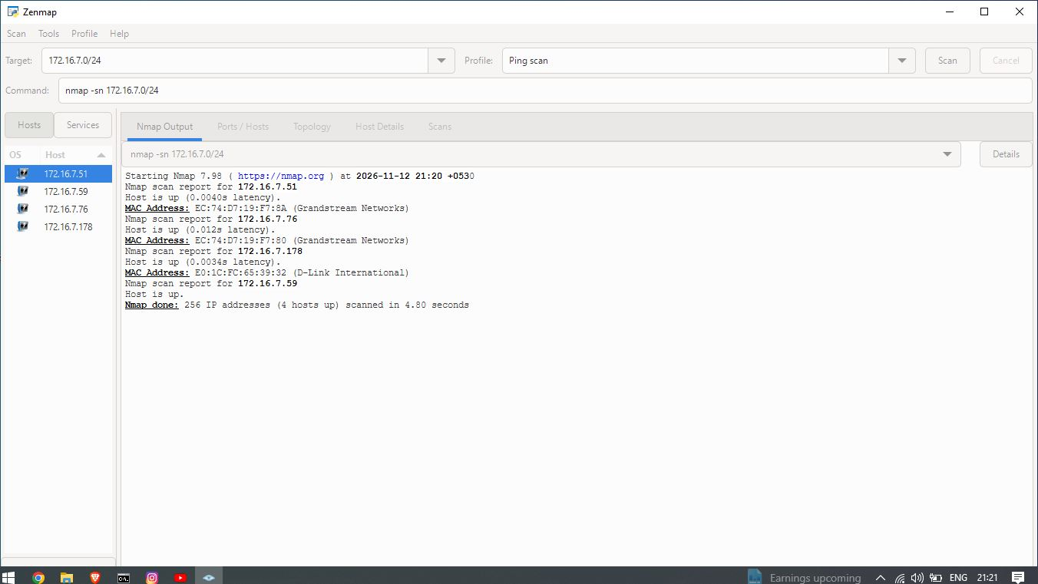

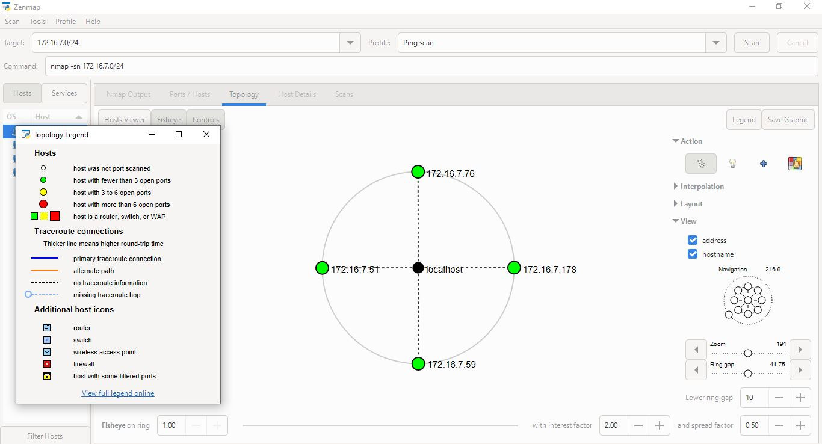
-End-

👤 Author
YASH RAJ
Cybersecurity Professional B084
LinkedIn: https://www.linkedin.com/in/yash-raj-ba4414312/

📌 Project Information
Program Name: Cybersecurity program at Networkwalks | Week: 02 | Repository: GitHub

